**DOCUMENTATION FOR SCENARIO-1:**

* **What is Scenario-1?**
* **Alice is a new user to the WINGS WORKFLOW SYSTEM.**
* **She just created a new WORKFLOW in WINGS that does SORTING using different algorithms.**

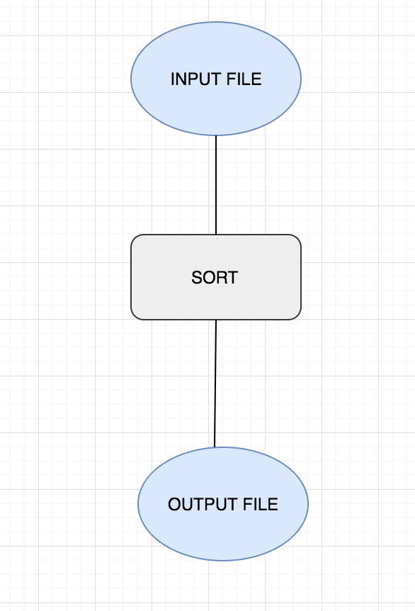

* **She now decides to execute that workflow using QuickSort.**

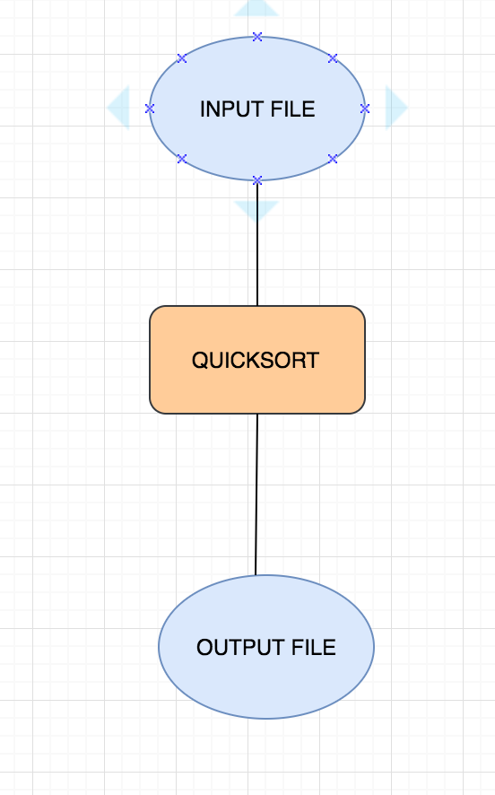

* **She enjoyed executing that workflow and so she decides she wants to use another input file to check whether it works again. So she again executes the same workflow again with QuickSort.**



* **She now knows that this is working really well. She further decides to execute the workflow again, but this time with MergeSort.**

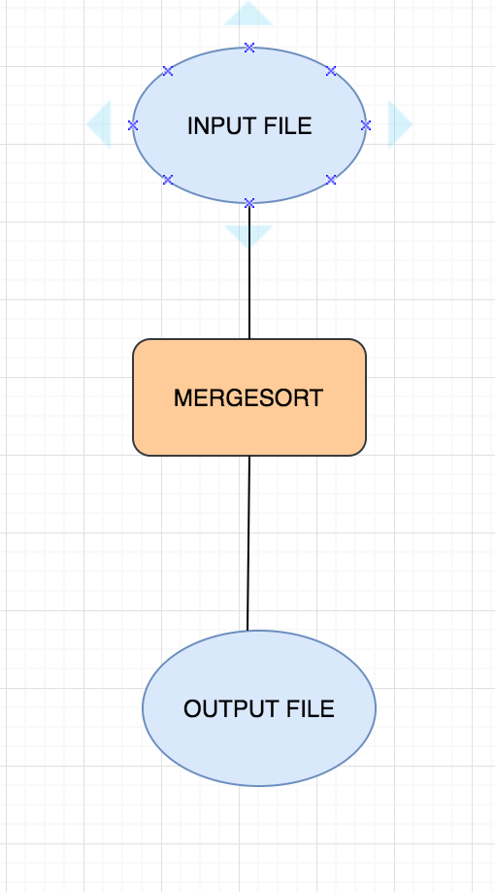

* **She is thrilled to know that it works again even with MergeSort.**

**QUESTIONS/QUERIES TO UNDERSTAND NOW:**

* **Q1: How many abstract templates did she create in this entire procedure?**
* **Ans: Well, she just created only 1 abstract template.**
* **Q2: How many expanded templates did she create in this procedure?**
* **Ans: She has created 2. One with QuickSort and other with MergeSort.**
* **Q3: How many executions did she create in this procedure?**
* **Ans: She has created 3 executions in this case, 2 with QuickSort and 1 with MergeSort.**

**IMPORTANT ASPECTS ABOUT THE CODE:**

* **We have created a signature to identify the uniquely created expanded templates.**
* **Q: How is the signature created?**
* **Ans: The signature is created by taking in all the important relations like inputlinks, outputlinks, datavariables, parameters, and components with the derived from relations (connection to the abstract template). We then take an arrayList of all these strings. We further hash this string with MD5. Now it’s going to be maintained as UNIQUE.**
* **We are currently extracting all aspects of the Expanded Template and seeing to it that the URIs are very well defined and do not clash or go wrong in any way.**
* **The testing queries are maintained in the Validations folder in the GitHub Repository. Please see to it you upload all the necessary results from the mapper in the case when you want to try out anything in the testing cases.**

**QUERIES FOR SCENARIO-1:**

* **How many executions, abstract templates and expanded templates exist?**

**VALIDATION TEST EXPECTATIONS:**

* **We first need to create a repository of abstract templates, their executions. Further include all the results from the mapper i.e. the result of the template function and the execution function into the repository.**
* **For example, if we create a template as shown above with SORT as an abstract component. Then store that in the repository (.owl file) and lets assume that we executed that abstract template in WINGS using Merge Sort once and next time using Quick Sort. Now, add both the execution files and the results from the execution function of the mapper in the repository.**
* **Now create a new execution of that abstract template with Bubble Sort and a 4th one with Merge Sort again.**
* **So currently the repository contains 1 abstract template, 4 execution files from the executions in WINGS. It also contains, 1 resulting file of the mapper template function that was executed from the mapper. It also contains 4 execution result files from the mapper execution function.**
* **Now SCENARIO-1’s major concept is to identify how many executions are there, how many expanded templates got created and finally, how many abstract templates exist?**
* **The result of a validation test asking for the 3 above questions should give a result of:**

1. **Abstract templates are: (1)**
2. **Expanded Templates are: (3)**
3. **Executions are: (4)**